1. What is a Messaging Service?
A Messaging Service enables asynchronous communication between applications by exchanging messages through an intermediary system (broker).
Key idea:
- Sender and receiver do not talk directly
- Messages are stored, routed, delivered reliably
Why Messaging?
- Loose coupling
- Scalability
- Fault tolerance
- Async processing
- Event-driven architecture
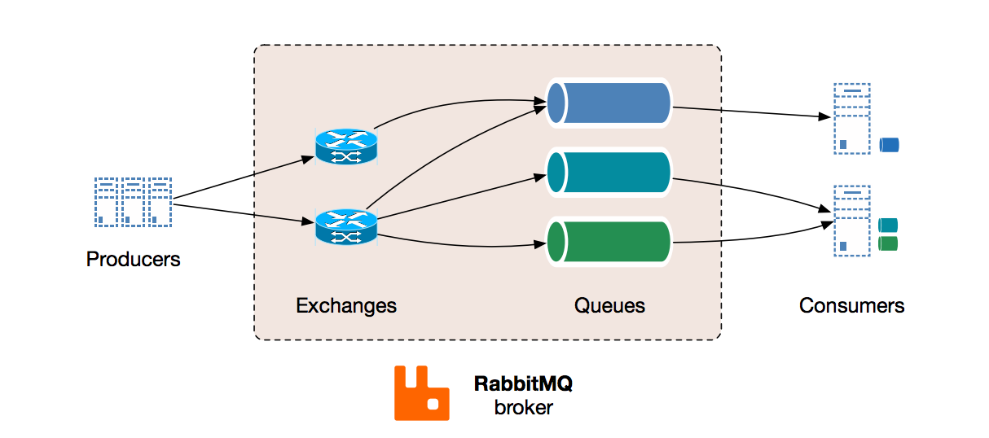
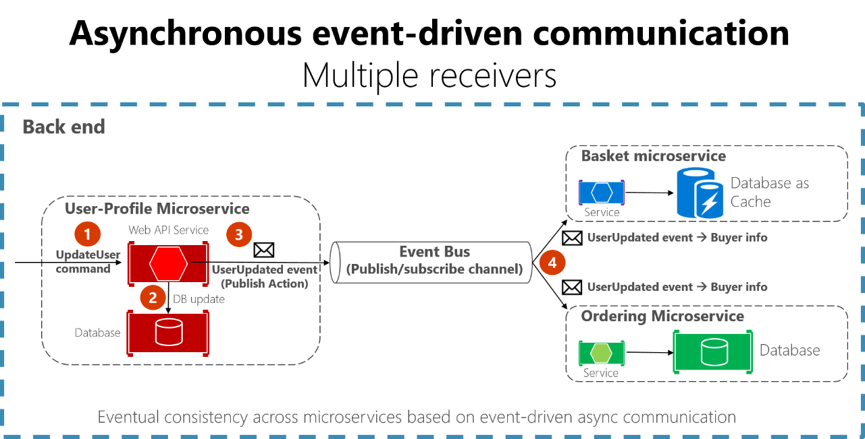

2. What is MOM (Message Oriented Middleware)?
MOM is software that acts as a middle layer between applications to handle message delivery.
It provides:
- Message queues or topics
- Reliable delivery
- Persistence
- Routing
- Acknowledgement
- Retry & fault tolerance
Examples:
- Apache Kafka
- RabbitMQ
- ActiveMQ
- IBM MQ
- Amazon SQS

3. MOM Communication Models
3.1 P2P (Point-to-Point)
- Messages go to a queue
- Only one consumer receives a message
- Used for task processing
Flow:
Producer → Queue → Consumer
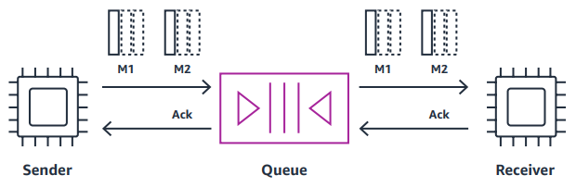
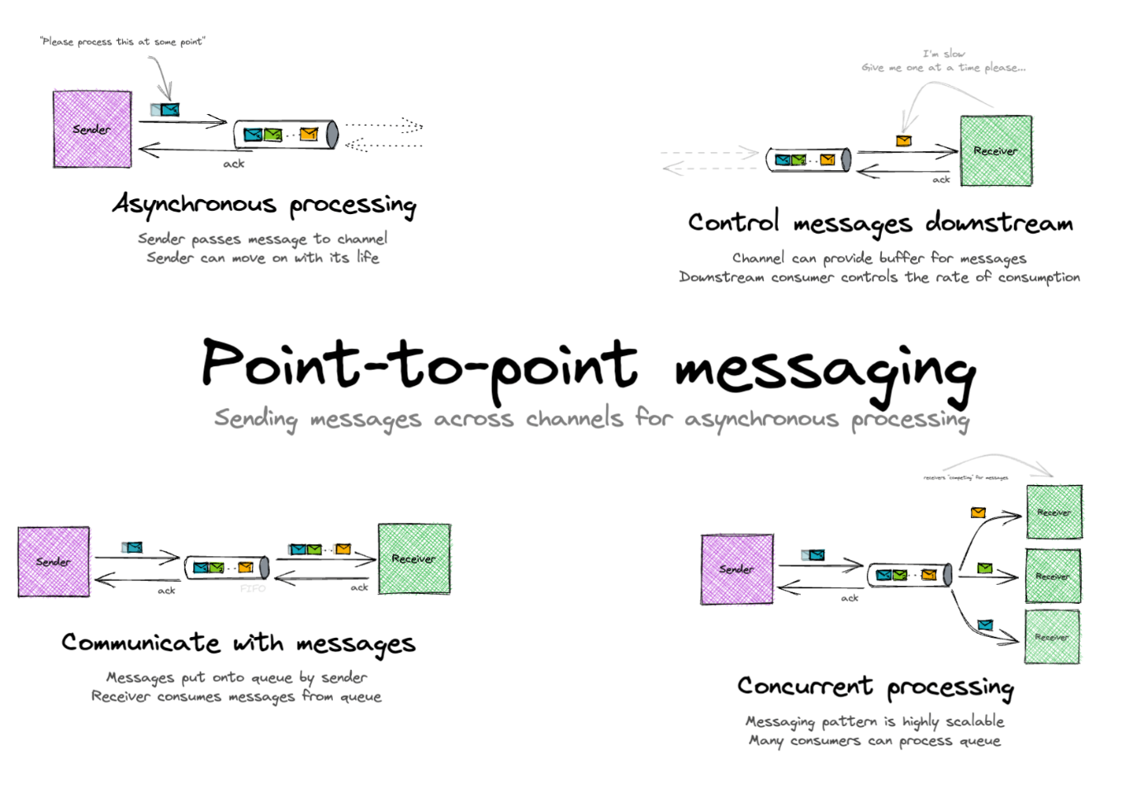

Real use case
- Order processing
- Payment processing
- Background jobs

3.2 Pub/Sub (Publish & Subscribe)
- Messages go to a topic
- Multiple consumers receive the same message
- Used for event broadcasting
Flow:
Producer → Topic → Multiple Subscribers
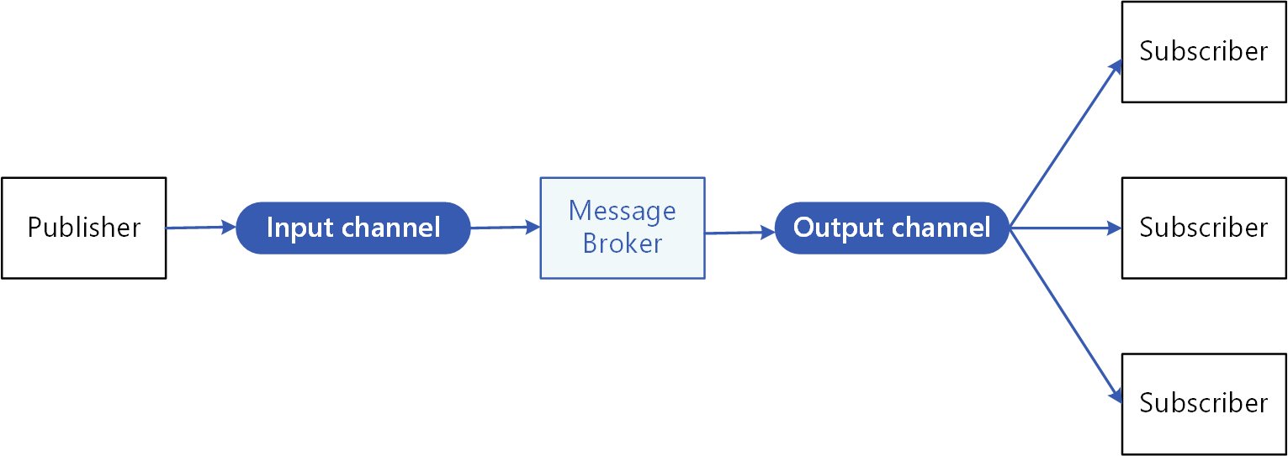
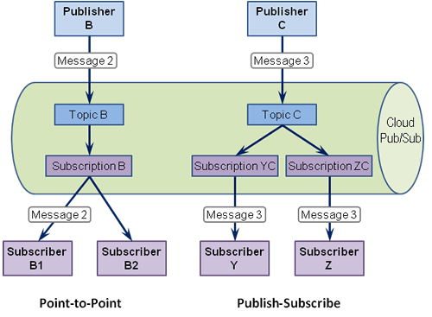
Real use case
- Notifications
- Event streaming
- Analytics
- Logs

4. Examples of MOM Technologies
Technology | Model | Typical Use
Apache Kafka | Pub/Sub (log-based) | Event streaming, big data
RabbitMQ | P2P + Pub/Sub | Microservices
ActiveMQ | P2P + Pub/Sub | JMS apps
IBM MQ | P2P | Banking
Amazon SQS | P2P | Cloud workloads

5. What is Apache Kafka?
Apache Kafka is a distributed event streaming platform designed for:
- High throughput
- Durability
- Horizontal scalability
- Real-time data streaming
Kafka is not a traditional queue.
It is a distributed commit log.
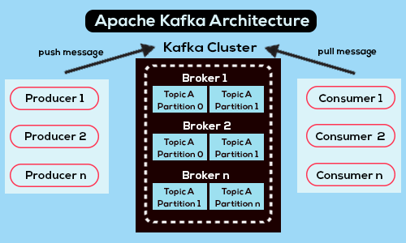
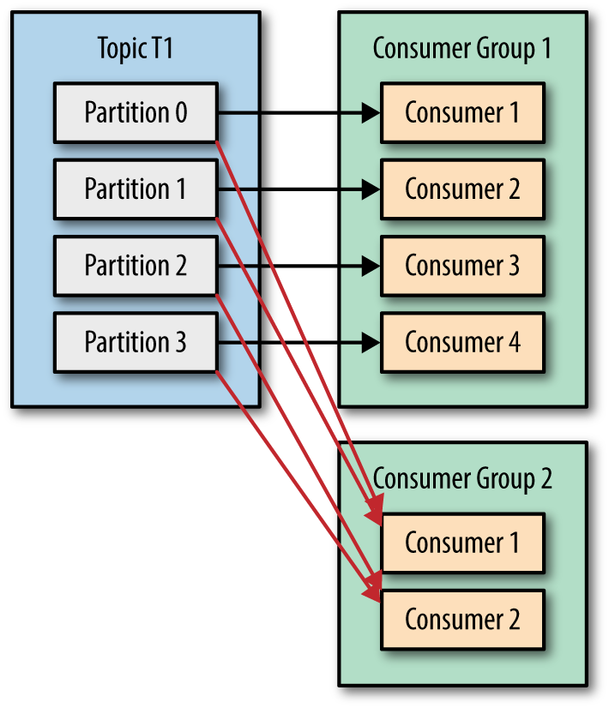

6. Core Kafka Concepts (Must Know)
Concept | Meaning
Topic | Logical message category(container to hold the message)
Partition | Ordered, immutable log
Producer | Sends messages
Consumer | Reads messages
Consumer Group | Parallel consumption
Offset | Position in partition
Broker | Kafka server
Zookeeper / Kraft | Metadata management

7. Kafka vs Other MOM Technologies
Feature | Kafka | RabbitMQ | ActiveMQ
Message retention | Time-based | Until consumed | Until consumed
Throughput | Very high | Medium | Medium
Replay messages | Yes | No | No
Ordering | Per partition | Per queue | Per queue
Streaming | Excellent | Limited | Limited
Big data | Native | Not suitable | Not suitable
Kafka is preferred when
- Event streaming
- Analytics
- Logs
- Real-time pipelines
- Microservices events

1. Apache Kafka (Platform)
Definition
Apache Kafka is a distributed event-streaming platform used to publish, store, process, and consume events in real time.
Use case
- Event-driven microservices
- Real-time analytics
- Log aggregation
- Data pipelines

2. Broker
Definition
A broker is a Kafka server that:
- Stores data
- Serves producers and consumers
- Manages partitions and replicas
Each Kafka cluster has multiple brokers.
Use case
- Horizontal scaling
- High availability
- Load distribution

3. Topic
Definition
A topic is a logical channel/category to which producers send messages and from which consumers read messages.
Topics are append-only.
Use case
- orders-topic for order events
- payments-topic for payment events
- logs-topic for application logs

4. Partition
Definition
A partition is a physically ordered, immutable sequence of messages inside a topic.
Each partition:
- Maintains order
- Is distributed across brokers
- Enables parallelism
Use case
- High throughput
- Parallel consumers
- Scaling data volume

5. Offset
Definition
An offset is a unique sequential number assigned to each message within a partition.
Offsets are consumer-controlled, not deleted after reading.
Use case
- Message replay
- Fault recovery
- Exactly-once processing

6. Producer
Definition
A producer publishes messages to Kafka topics.
Producers can:
- Send messages with or without keys
- Choose partitioning strategy
- Configure reliability (acks)
Use case
- Order service sending order events
- Payment service publishing payment status
- Logging framework pushing logs

7. Consumer
Definition
A consumer reads messages from topics.
Consumers:
- Pull data (not push)
- Track offsets
- Belong to consumer groups
Use case
- Order processing service
- Notification service
- Analytics engine

8. Consumer Group
Definition
A consumer group is a logical group of consumers that jointly consume a topic.
Each partition is read by only one consumer per group.
Use case
- Load balancing
- Horizontal scaling
- Microservices deployments

9. Leader Partition
Definition
Each partition has one leader broker that handles:
- Read requests
- Write requests
Use case
- Single source of truth
- Consistent ordering

10. Follower Partition (Replica)
Definition
Follower partitions replicate data from the leader for fault tolerance.
Use case
- High availability
- Automatic failover

11. Replication Factor
Definition
The replication factor defines how many copies of a partition exist across brokers.
Use case
- Data durability
- Disaster recovery

12. ISR (In-Sync Replicas)
Definition
ISR is the set of replicas that are:
- Fully caught up with the leader
- Eligible to become leader
Use case
- Safe leader election
- Data consistency

13. Controller
Definition
The controller is a special broker responsible for:
- Leader election
- Partition reassignments
- Broker failure handling
Use case
- Cluster coordination
- Automatic recovery

14. Zookeeper / KRaft
Zookeeper (Legacy)
Definition
Zookeeper managed:
- Broker metadata
- Leader election
- Configuration storage
KRaft (Modern)
Definition
KRaft is Kafka’s built-in consensus layer, replacing Zookeeper.
Use case
- Simplified deployment
- Better scalability
- Reduced operational complexity

15. Log Segment
Definition
Each partition is split into log segments stored on disk.
Segments are immutable once closed.
Use case
- Efficient disk usage
- Faster reads
- Log compaction

16. Retention Policy
Definition
Retention defines how long Kafka keeps data:
- Time-based
- Size-based
Use case
- Compliance
- Storage optimization
- Replay window

17. Log Compaction
Definition
Log compaction retains latest value per key, deleting older records.
Use case
- Configuration updates
- User profile latest state
- Cache rebuilds

18. Message Key
Definition
A key determines the partition to which a message is written.
Same key → same partition → ordering guaranteed.
Use case
- Order lifecycle events
- Customer-specific events

19. Message Value
Definition
The value is the actual payload (JSON, Avro, String, etc.).
Use case
- Business data
- Event information

20. Message Headers
Definition
Headers are metadata key-value pairs attached to messages.
Use case
- Event type
- Source system
- Routing information

21. Acknowledgements (acks)
Definition
acks defines producer write confirmation:
- 0 no confirmation
- 1 leader only
- all all replicas
Use case
- Trade-off between performance and reliability

22. Idempotent Producer
Definition
Ensures messages are written exactly once, even with retries.
Use case
- Financial transactions
- Payment systems

23. Exactly-Once Semantics (EOS)
Definition
Kafka guarantees messages are processed exactly once.
Use case
- Banking
- Billing
- Inventory systems

24. Kafka Streams
Definition
A client library for real-time stream processing.
Use case
- Aggregations
- Joins
- Windowing operations

25. Kafka Connect
Definition
Kafka Connect is a framework for integrating external systems with Kafka.
Use case
- Database → Kafka
- Kafka → Elasticsearch
- Kafka → Data lake

26. Schema Registry (Optional Component)
Definition
Manages schemas (Avro/JSON/Protobuf) for Kafka messages.
Use case
- Schema evolution
- Data compatibility
- Governance

27. CLI Tools
Definition
Kafka provides command-line tools for managing topics, producers, consumers, and clusters.
Use case
- Admin operations
- Debugging
- Learning Kafka internals

28. Metrics & Monitoring
Definition
Kafka exposes metrics via JMX.
Use case
- Consumer lag monitoring
- Broker health
- Throughput analysis

Final Big Picture
Layer | Components
Client | Producer, Consumer, Streams
Data | Topic, Partition, Offset
Cluster | Broker, Controller, ISR
Reliability | Replication, acks, EOS
Integration | Connect, Schema Registry

8. Apache Kafka Setup Using Docker (Recommended)
8.1 Prerequisites
- Docker installed
- Docker Compose installed

Create the docker compose file

docker-compose.yml
services:
zookeeper:
image: confluentinc/cp-zookeeper:7.5.0
environment:
ZOOKEEPER_CLIENT_PORT: 2181

kafka:
image: confluentinc/cp-kafka:7.5.0
depends_on:
- zookeeper
ports:
- "9092:9092"
environment:
KAFKA_BROKER_ID: 1
KAFKA_ZOOKEEPER_CONNECT: zookeeper:2181
KAFKA_ADVERTISED_LISTENERS: PLAINTEXT://localhost:9092
KAFKA_OFFSETS_TOPIC_REPLICATION_FACTOR: 1

8.3 Start Kafka
docker-compose up -d

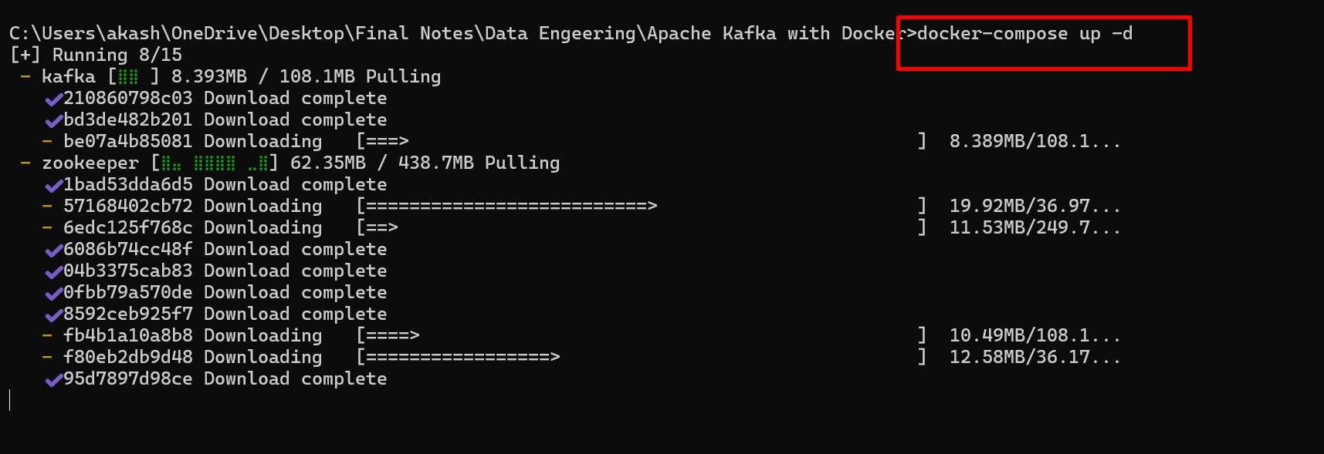

Verify:
docker ps

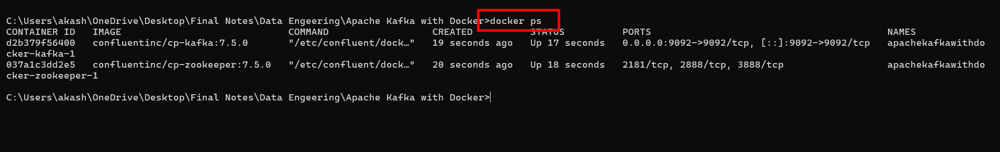

Kafka Command Line Programs (Step-by-Step)
9.1 Enter Kafka Container
docker exec -it kafka bash
kafka is contains name or container id running with port number 9092
please check your machine container name or container id.

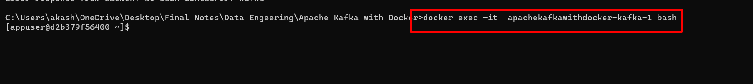

kafka-console-producer --topic basic-topic --bootstrap-server localhost:9092
kafka-console-producer is a command to connect Apache kafka through command prompt we can connect using python, java, C# etc.
basic-topic is topic name
localhost : Kafka running on which machine that machine name or ip address.

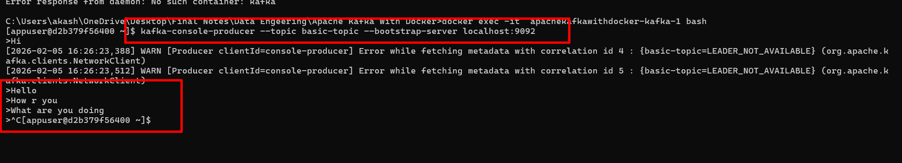

What it does
- Starts a simple producer
- Sends messages without key
- Messages go to partitions round-robin
Use case
Simple log publishing
- Application logs
- Debug messages
- Learning & testing Kafka

Example input
- User logged in
- User logged out

2. Basic Consumer Command
Command
kafka-console-consumer --topic basic-topic --bootstrap-server localhost:9092



What it does
- Consumes only new messages
- Starts from latest offset
Use case
Live monitoring
- Watching logs
- Monitoring events in real time

3. Consumer from Beginning
Command
kafka-console-consumer --topic basic-topic --from-beginning --bootstrap-server localhost:9092

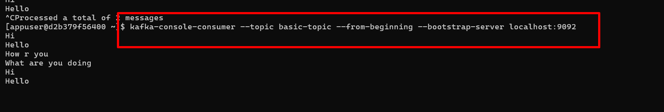

What it does
- Reads all existing messages
- Starts from offset 0
Use case
Audit / replay
- Debug issues
- Reprocessing old events
- Data validation

4. Producer with Acknowledgement Awareness (Implicit)
Kafka producer waits for broker ACK by default.
Use case
Guaranteed delivery
- Financial events
- Order creation messages

INTERMEDIATE LEVEL
(Keys, consumer groups, partitions)

5. Producer with Message Key
Command
kafka-console-producer --topic orders-topic --bootstrap-server localhost:9092 --property "parse.key=true" --property "key.separator=:"

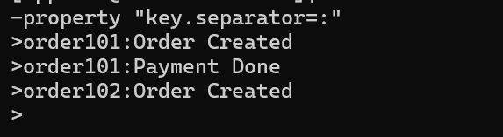

What it does
- Uses key for partitioning
- Same key → same partition → ordering guaranteed
Use case
Order lifecycle
- Order created
- Payment
- Shipping
(All must stay in order)

Consumer with Consumer Group
- Command

kafka-console-consumer --topic orders-topic --group order-service --bootstrap-server localhost:9092

What it does
- Joins consumer group
- Kafka tracks offsets per group
- Enables parallel consumption
Use case
Microservices
- Multiple instances of order-service
- Load balancing automatically

7. Multiple Consumers – Load Balancing
Run the same command in 2 terminals:
kafka-console-consumer --topic orders-topic --group order-service --bootstrap-server localhost:9092

What happens
- Partitions are distributed
- Each message goes to only one consumer
Use case
High-throughput systems
- Payment processing
- Inventory update services

8. Consumer Group Offset Tracking
Command

kafka-consumer-groups --describe --group order-service --bootstrap-server localhost:9092

What it shows
- Current offset
- Log end offset
- Lag
Use case
Operations & monitoring
- Detect slow consumers
- Prevent data backlog

9. Consumer with Auto Commit Disabled
Command

kafka-console-consumer --topic orders-topic --group order-service
--bootstrap-server localhost:9092 --property enable.auto.commit=false

What it does
- Consumer does not auto-commit
- Manual offset control needed (advanced apps)
Use case
Exactly-once processing
- Payment systems
- Banking transactions

ADVANCED LEVEL
(Offsets, partitions, headers, performance)

10. Consume from Specific Partition & Offset
Command

kafka-console-consumer --topic orders-topic --partition 1 --offset 0 --bootstrap-server localhost:9092

What it does
- Reads specific partition
- Reads from a specific offset
Use case
Targeted debugging
- Investigate corrupted messages
- Replay only failed partition

11. Reset Consumer Group Offsets
Command

kafka-consumer-groups --bootstrap-server localhost:9092 --group order-service --topic orders-topic --reset-offsets --to-earliest –execute

What it does
- Resets offsets to beginning
- Consumer will reprocess all messages
Use case
Disaster recovery
- Bug fixed → reprocess data
- Data pipeline correction

12. Producer with Message Headers
Command

kafka-console-producer --topic orders-topic --bootstrap-server localhost:9092 --property "parse.headers=true" --property "headers.separator=,"

Input
event=created,source=web Order placed
event=shipped,source=mobile Order shipped

What it does
- Adds metadata headers
- Headers are not part of message body
Use case
Event classification
- Routing logic
- Filtering in stream processors

13. Consumer Printing Key, Value & Headers
Command

kafka-console-consumer --topic orders-topic --from-beginning
--bootstrap-server localhost:9092 --property print.key=true --property print.value=true --property print.headers=true

Use case
Debugging & auditing
- Inspect full message content
- Validate producer behavior

14. High Throughput Producer Test
Command

kafka-producer-perf-test --topic orders-topic --num-records 500000 --record-size 200 --throughput 20000 --producer-props bootstrap.servers=localhost:9092

What it does
- Stress tests producer
- Measures throughput & latency
Use case
Capacity planning
- Production readiness
- Load testing Kafka clusters

15. Consumer Lag Monitoring (Operational)
Command

kafka-consumer-groups --bootstrap-server localhost:9092 --all-groups --describe

Use case
Production monitoring
- Identify slow services
- Prevent SLA breaches

REAL-TIME MAPPING (Industry)
Scenario | Producer | Consumer
Order system | Sends order events | Order service
Payment gateway | Sends payment status | Billing service
Notification | Sends event | Email / SMS
Analytics | Sends logs | Spark / Flink
Audit | Sends all events | Compliance

